**The Chesapeake Bay**

**Bay History**

The Chesapeake region has been around for a very long time. Many tend to begin its history with the establishment of Jamestown, Virginia, in 1607. But the story of the Bay began millions of years before that.

**The Bay Ecosystem**

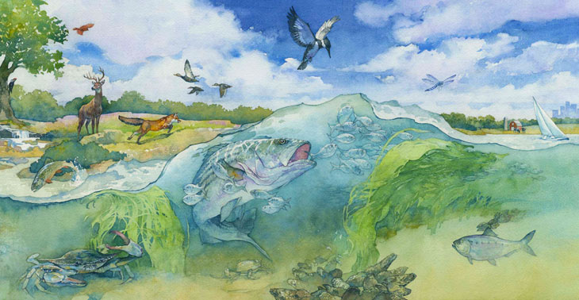*Illustration by Greg Harlin, Wood Ronsaville Harlin, Inc.*

An ecosystem is a complex set of relationships among living and non-living things. Air, water, soil, sunlight, plants and animals – including humans – make up an ecosystem. Ecosystems can be as tiny as a patch of dirt in your backyard, or as large as the entire Chesapeake Bay watershed.

The Chesapeake Bay, the largest estuary in the United States, is an extremely productive and complex ecosystem. The Bay ecosystem consists of the Bay itself, its local rivers and streams, and all the plants and animals it supports.

Like any other system, an ecosystem is composed of interrelated parts that interact with each other to form a whole. All of the plants and animals in an ecosystem depend on each other in some way. For example, predators eat prey, and animals find shelter among plants. Even the smallest creatures play an important role in their ecosystem.

Every living thing needs a healthy ecosystem to survive. Human activities affect the Chesapeake Bay ecosystem by adding pollution, using resources and changing the character of the land. However, we can make better choices in our everyday lives to lessen our footprint on the Bay ecosystem’s health.

**The Chesapeake Bay Watershed**

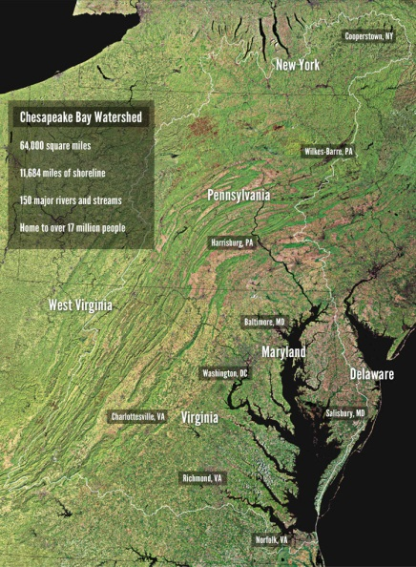

**What is a watershed?**

A watershed is an area of land that drains to a particular river, lake, bay or other body of water. Watersheds are sometimes called “basins” or “drainage basins.”

We all live in a watershed. Some watersheds, like that of your local stream or creek, are small. Others, like the Chesapeake Bay watershed, are very large.

**What is the Chesapeake Bay watershed?**

The Chesapeake Bay watershed stretches across more than 64,000 square miles. It encompasses parts of six states – Delaware, Maryland, New York, Pennsylvania, Virginia and West Virginia – and the entire District of Columbia. More than 17 million people live in the Chesapeake Bay watershed.

The Chesapeake Bay’s land-to-water ratio (14:1) is the largest of any coastal water body in the world. This is why our actions on the land have such a big impact on the Bay’s health.

**What are the major rivers in the Chesapeake Bay watershed?**

The Susquehanna, Potomac, Rappahannock, York and James rivers are the five largest rivers in the Chesapeake Bay watershed.

Altogether, more than 100,000 streams, creeks and rivers (called tributaries) thread through the Chesapeake Bay watershed. Each one of us lives within a few miles of one of these local waterways, which are like pipelines from our communities to the Bay.

Each of the streams, creeks and rivers in the Chesapeake Bay watershed has its own watershed. These are sometimes called “sub-watersheds,” “small watersheds” or “local watersheds.”